Title: Fire and Rescue Service Secondary fires in Oxford City, April 2018 – March 2020

Source: Oxfordshire Fire and Rescue Service

Notes: Consultation areas are in yellow.

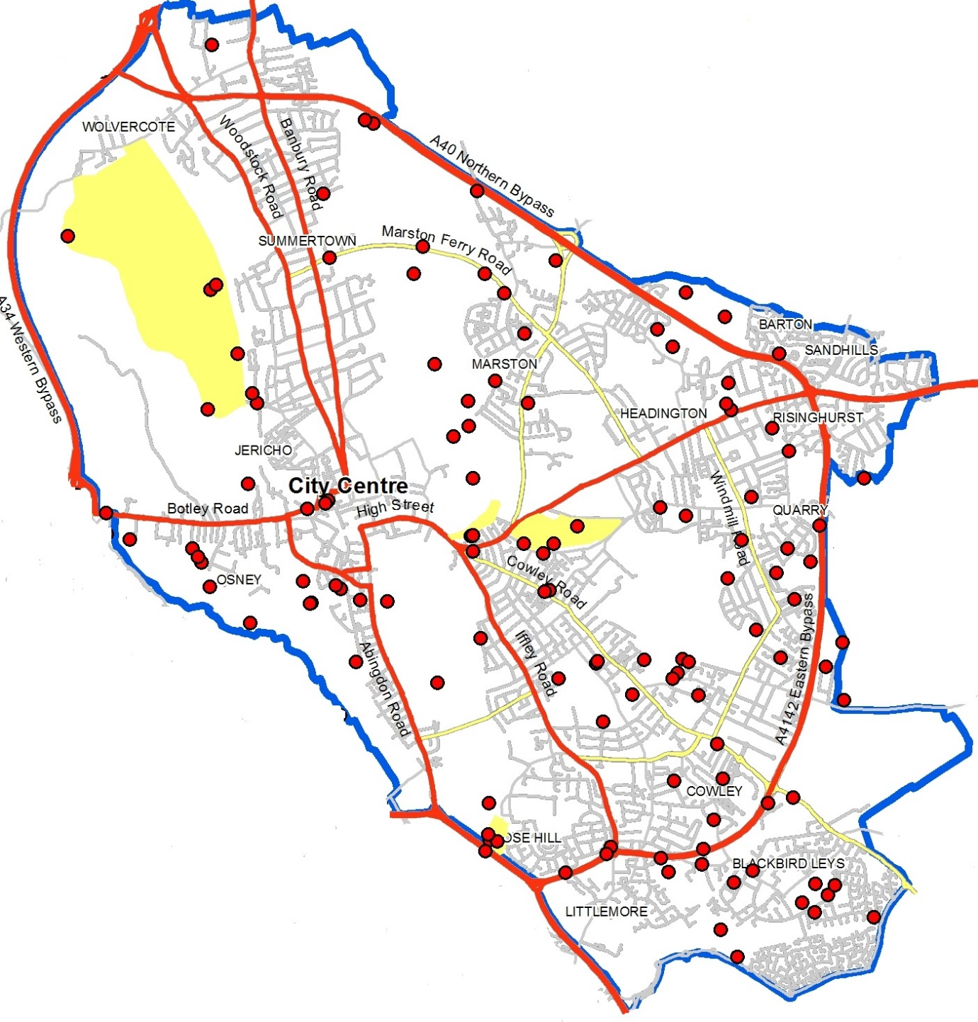

Source: Oxford Direct Services Countryside Rangers Team

Note: Commentary on the impact of fires on Sites of Special Scientific Interest

The scorching is an issue on a Site of Special Scientific Interest (SSSI) which is a statutory designation that puts a duty of care on the landowner. Scorching causes damage to the grassland and associated plants. Additional issues being litter left from disposable BBQs.

We have also had the fire Brigade called out several times last year for fires in Burgess Field Nature Reserve. This is a former landfill site with a range of scrub and grassland habitat. This area becomes very dry during the summer and poses a large fire risk next to the mainline railway.

Source: Friends of South Parks

Note: Photos and commentary on the impact of fires in South Park

Tray BBQs

Damage the grass beneath them - there is clear evidence of this after their use and is reflected in the photos on the laminated signs attached to the Park fence by the entrances. They are dangerous (hot) to other Park users if left in situ after use. Food rubbish is often left around them and the smells and smoke emitted during use pollute the neighbouring gardens on Morrell Ave due to the prevailing winds.

Fires/BBQs -

One Member/ Morrell Ave resident has recalled a BBQ getting out of control among the trees close by the garden fence. This was associated with wider Anti-Social Behaviour (ASB) involving alcohol (&other drugs?) leading to Burglary of and theft from several sheds; property was later found on fire. Incident was reported to police and there will be crime report evidence if needed in support of PSPO.

Another Member points out that fires have often been the focal point for a range of other ASB: noise, littering, damage to trees and park equipment (bench/litter bins destroyed in 2020) to fuel the fire. A Tesco trolley acted as grill. The larger fires tend to be lit and “enjoyed” overnight, the sound of said enjoyment carrying over to Morrell Avenue residents.

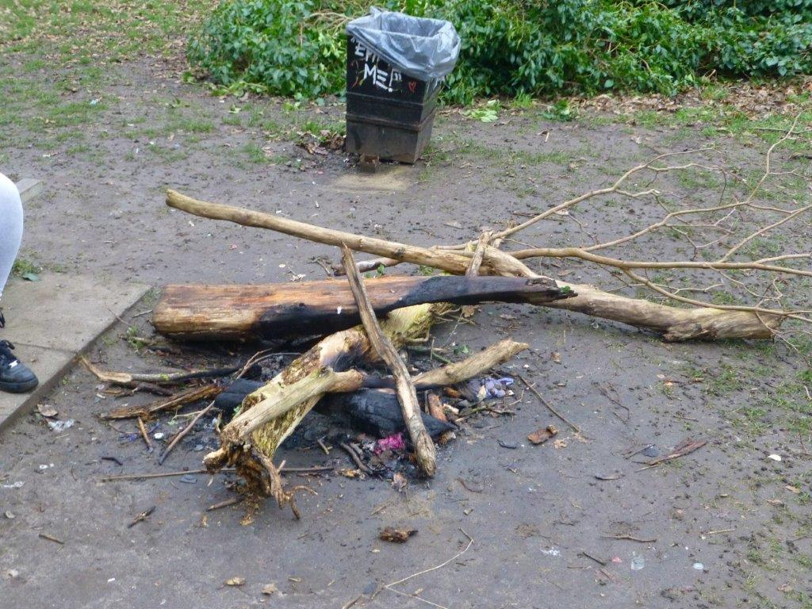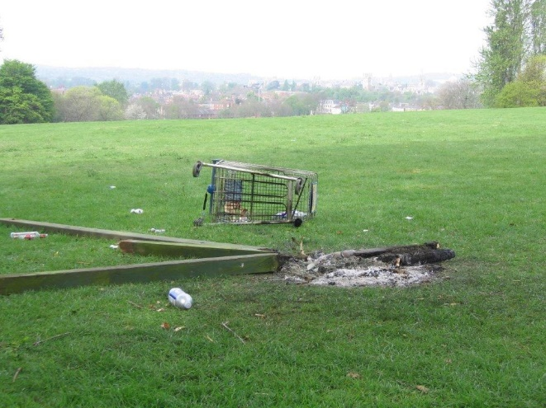

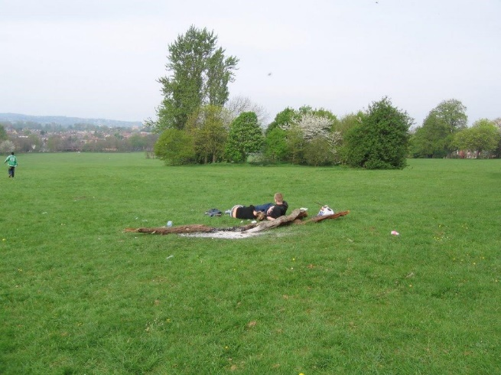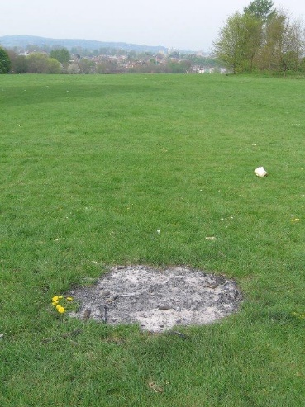

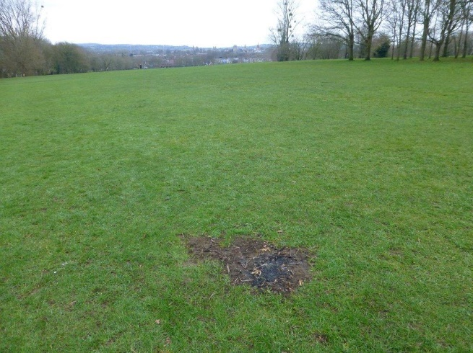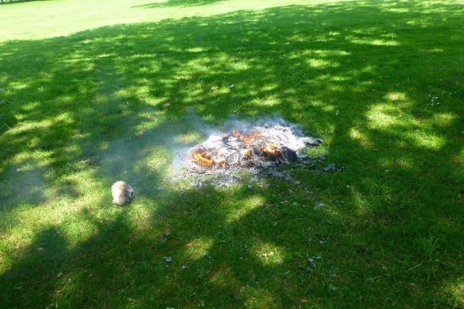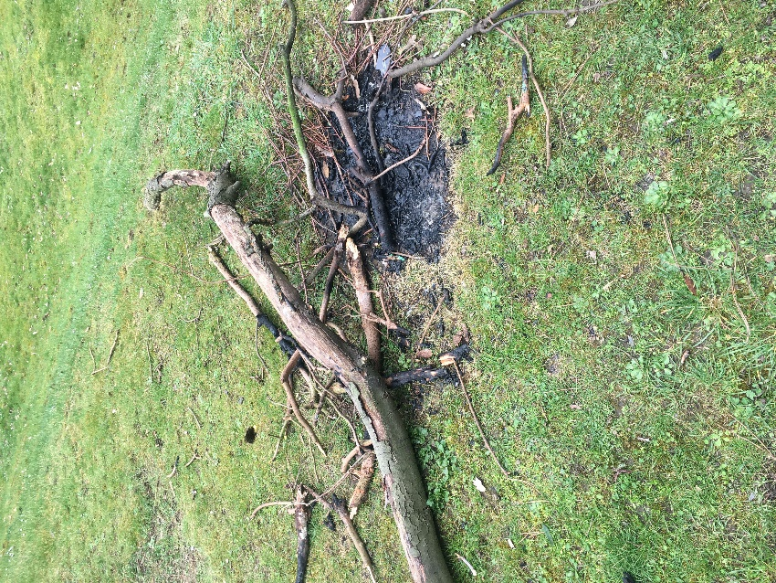

**Port Meadow, Burgess Field and Wolvercote Common**

Source: Port Meadow and Wolvercote Common Management Group

Notes: Photos and associated commentary on the impact of bottle digging and fire setting.

“We were asked at the meeting to provide justification for the imposition of an enforceable ban on fires and barbecues on Port Meadow, Wolvercote Common and Burgess Field in particular, and for Oxford’s green spaces generally.  Please find below my comments, not necessarily in order of importance:

1. Burgess Field is on the site of a rubbish dump, where uncontrolled dumping of household waste took place in the 1970s and early 1980s.  If this rubbish were to catch fire, it would potentially burn for years.  Nobody knows what potentially dangerous substances the dump contains.
2. The fires started on an almost daily basis on Burgess Field throughout last summer consist of large logs, mainly willow from the on-site pollarding, which are simply left to burn themselves out.  Unattended they burn for in excess of 24 hours.  Whenever well-intentioned members of the public alert the fire brigade, then the fire brigade is obliged to attend, which is an extraordinary waste of the precious time of this emergency service.
3. There is a risk, particularly in a dry summer period, that the fires will spread across the grassland areas, causing serious damage to wildlife and vegetation, and leaving a lasting eyesore.  This has already happened in previous years when fires and party gatherings were far, far less prevalent.
4. Of the rubbish cleared from Burgess Field this year, over 90% was left as the result of gatherings round these large log fires, which places an intolerable burden on the Friends of Burgess Field who have done all the clearing up.  The fines for littering are not effective in limiting this, as groups will always say when challenged ‘oh yeah, we’ll clear this up when we go’, which sadly they never do.
5. The fires are fuelled by logs taken from habitat piles intended to support insects and invertebrates, and by fallen branches, which should be allowed to rot down naturally.
6. The burnt vegetation, post barbecue or fire, is both unsightly and long-lasting, particularly on Port Meadow.

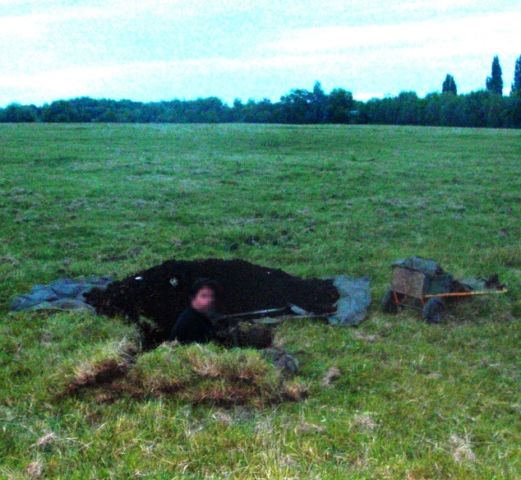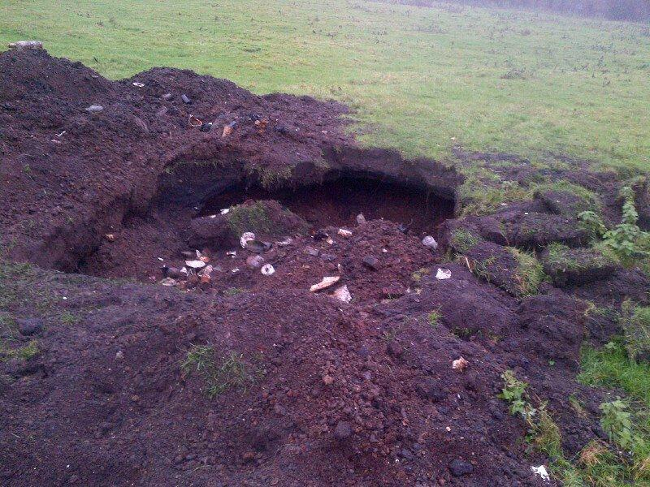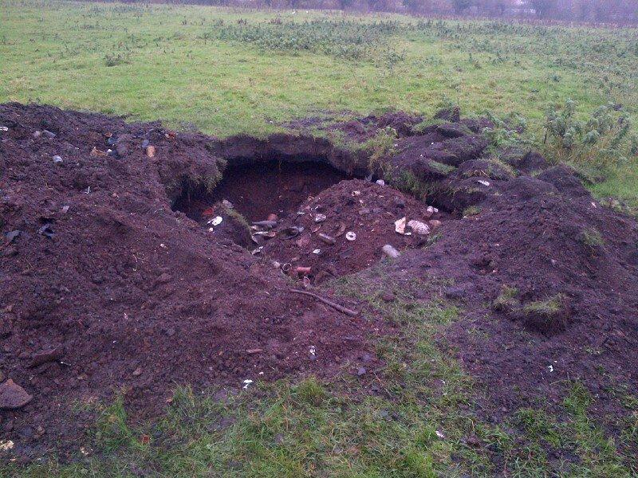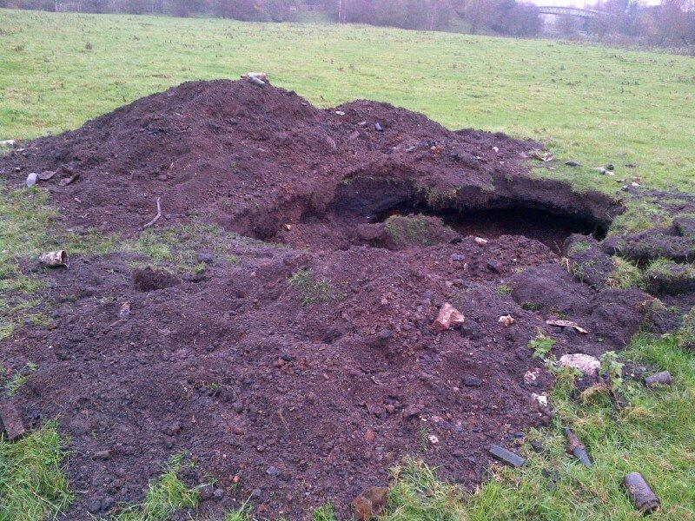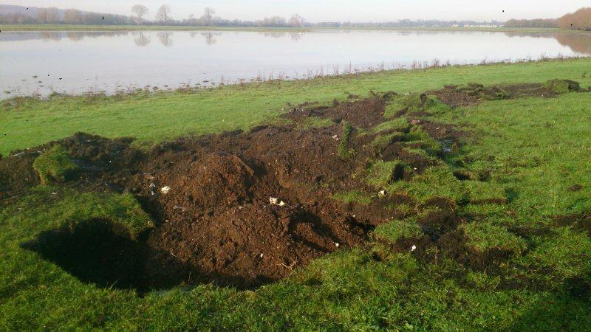

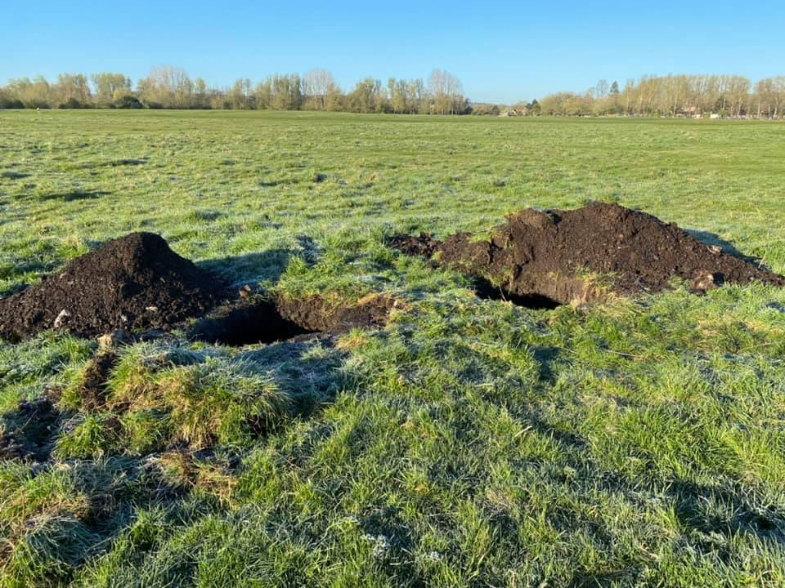

Bottle digging 15th April 2021

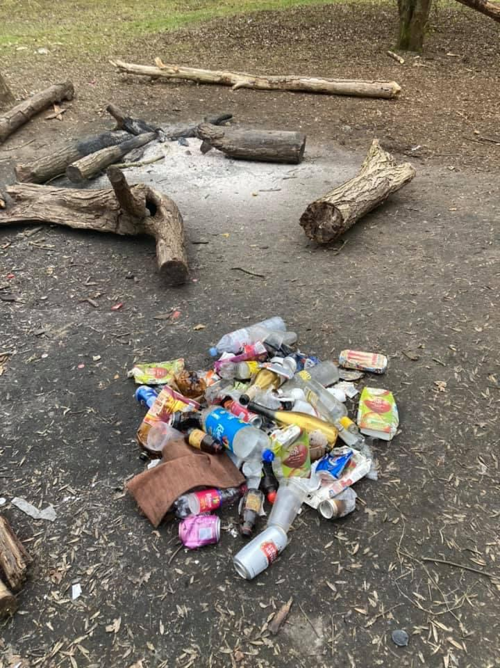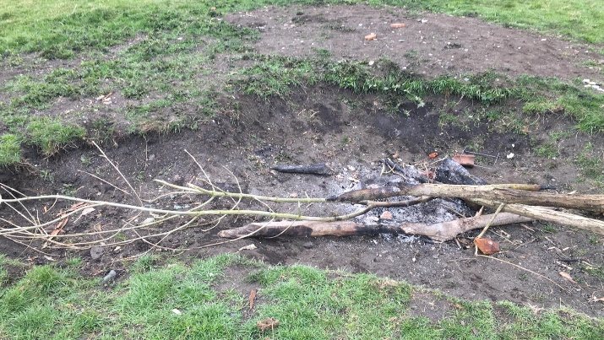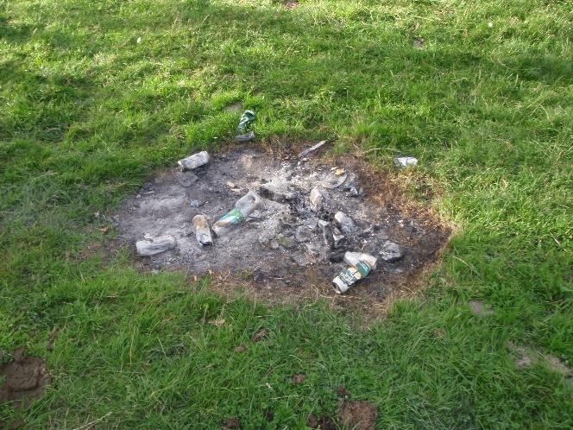

**Rivermead Nature Reserve**

Source: Oxford City Council officers

Notes: Photos of fire damage.

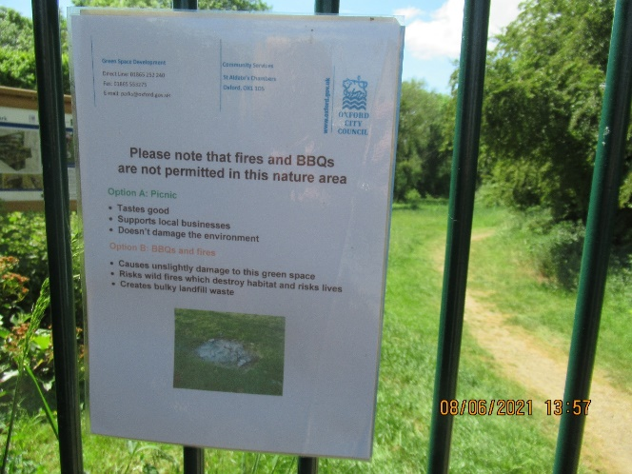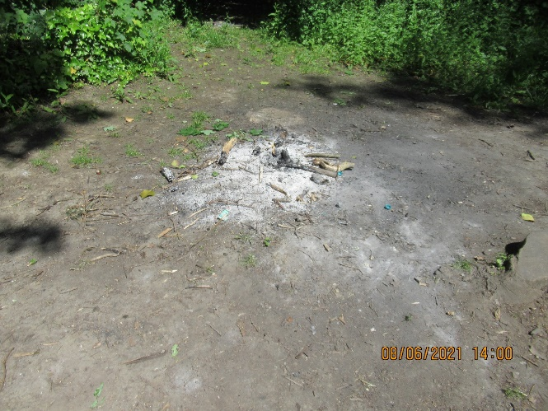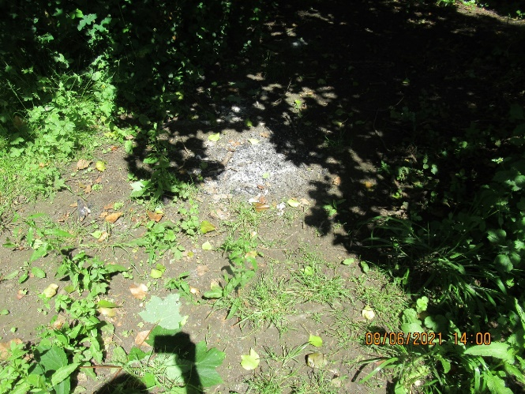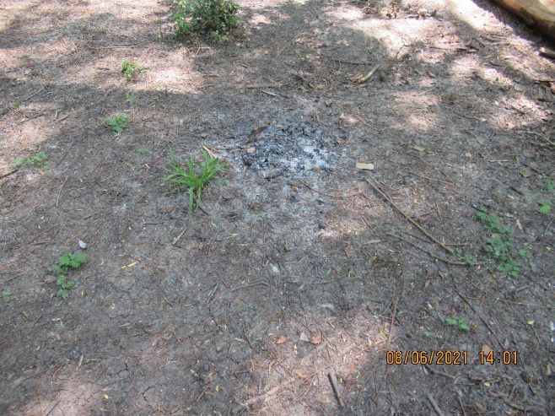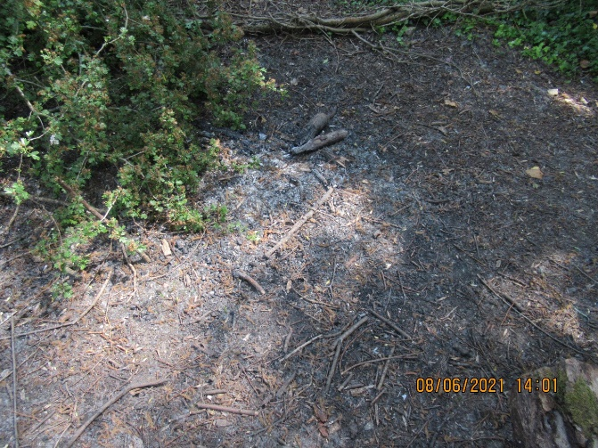

**Angel and Greyhound Meadow**

Source: Oxford City Council officers

Notes: Photos of fire damage.

